|  |  |  |  |  |  |  |
| --- | --- | --- | --- | --- | --- | --- |
| **Data**  **visualization**      **Energy Consumption Prediction using**  **Regression Analysis**  **Team 3**  **Team lead-A.Harshith Sai**    **Suggestion and finding**    The analysis of Energy Consumption Prediction using Regression Analysis A series of sheet  are developed to explore the impact of different factors  1. The dataset represents electric power consumption data of one household.  Measurements of electric power consumption in one household with a one-minute sampling rate over a period of almost 4 years. It contains 2,075,259 rows and 7 columns, gathered between December 2006 and November 2010 (47 months) we found following things  a. The voltage fluctuations of this particular household is approximately 29 volts i.e  223.49 to 252.14   * 1. The house hold has highest usage with submetering3 with the value of 5.93 on an average.   2. We can observe that average active power is greater than average reactive power that means the electronic gadgets are used for the most of the time      |  |  |  | | --- | --- | --- | | **Category** | **Active and reactive Powers** | **Sub metering 1,2,3** | | Findings from EDA | The maximum active power is 10.67 watt and the average active power is 1.108 watt    The maximum reactive power is 1.39 watt and the average active power is 0.118 watt | The highest values in sub metering  1,2,3 are 80,78 and 31 respectively    Mean(sub1)=1.177451350207658  Mean(sub2)==1.4751767821343296  Mean(sub3)==5.933836665370999 | |
| **Data**  **visualization**       |  |  | | --- | --- | | **Solution /efficiency** | 1. Replace older appliances with newer, more energyefficient models. Look for appliances with the   ENERGY STAR label, as they meet strict energy efficiency guideline   1. Consider installing voltage optimization devices to ensure that the voltage supplied to your household is within the optimal range. This can reduce energy consumption and increase the lifespan of appliances. 2. Improve insulation in your home to reduce heating and cooling demands. Seal any air leaks, and ensure windows and doors are properly insulated to maintain a comfortable temperature without excessive   reliance on HVAC systems   1. Ask your nearest substation people to reduce the fluctuations in voltages | |

The given data set Energy Consumption Prediction using Regression Analysis in this data set there are 9 parameters they are:

1.Date

2.Time

3.Global_active_power

4.Global_reactive_powr

5.Voltage

6.Global_intensity

7.Sub_metering 1

1. Sub_metering 2
2. Sub_metering 3

# Dataset

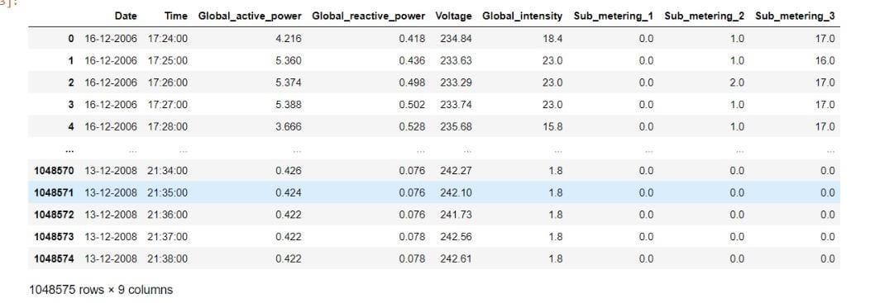

The above pictures shows the data set there are 1048575 rows of data.

This data may contain null values so to remove null values we have to do as shown in below picture

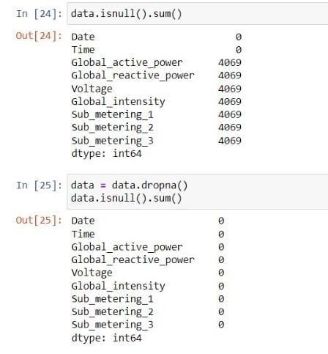

Now the picture says that there are 4069 null columns.

# Sub_metering 1 used in each month

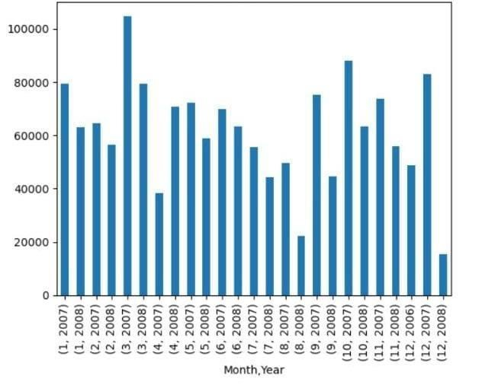

# observation

The above picture is Sub_metering 1 used in each month given in data set.

We can observe that Sub_metering 1 is mostly used in march 2008 and leastly used in dec 2008.

# Sub_metering 2 used in each month

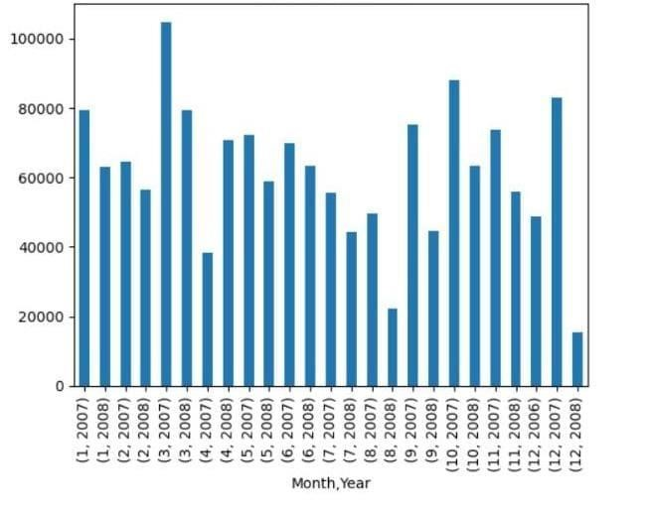 **observation**

The above picture is Sub_metering 2 used in each month given in data set.

We can observe that Sub_metering 2 is mostly used in march 2007 and leastly used in dec 2008.

# Sub_metering 3 used in each month

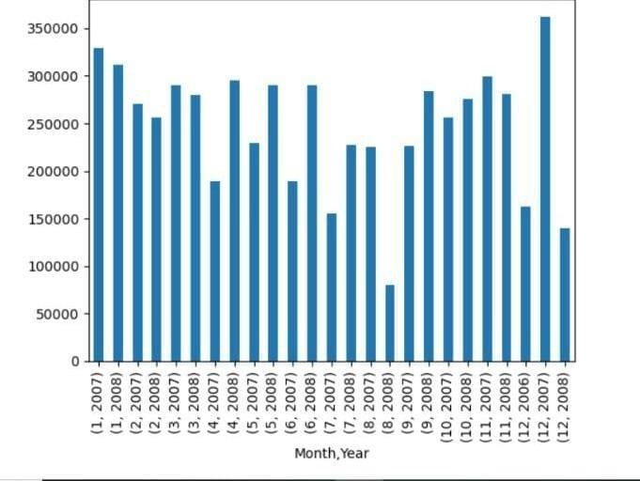 **observation**

The above picture is Sub_metering 3 used in each month given in data set.

We can observe that Sub_metering 3 is mostly used in dec 2008 and leastly used in aug 2008

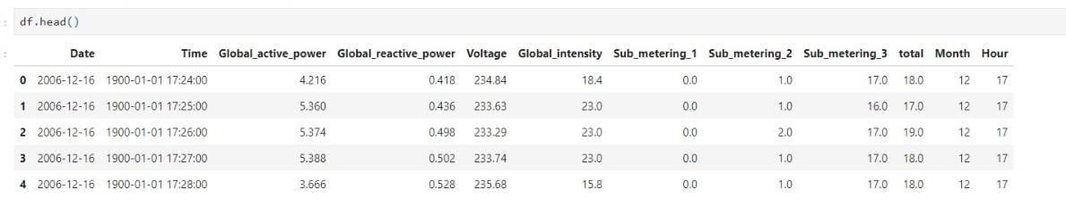 **observation**

The above picture shows the dataset after dividing total (which is sum of all metering’s), month, hour parameters

# observation

The above picture shows total of every month it concludes jan is the month which used most units and august is the lowest.

# observation

The above picture shows total of every month from data it concludes 10th month which used most units and 4th is the lowest.

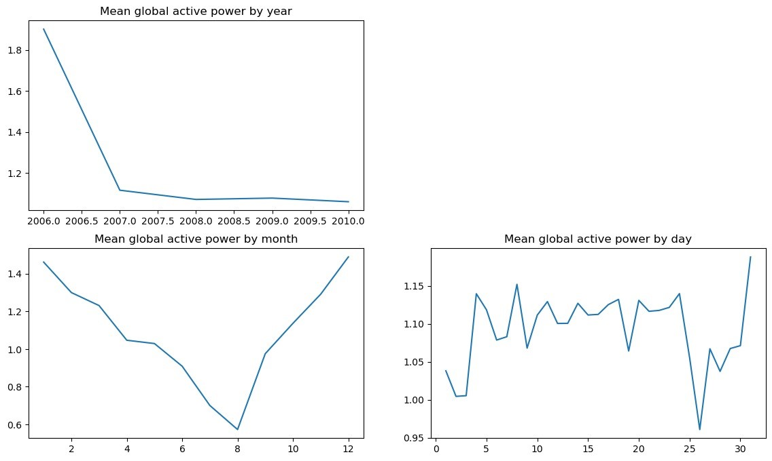 **observation**

The above pictures shows the mean global active power by year, month and day

It concludes that it is rapidly decreased from 2006 to 2007 and also go on decreasing after 2007 but at slow rate.

By seeing month data we can conclude that the graph decreases from jan to aug and increases then on to dec. it say that the usage of power decreases from jan to aug and increases then on to dec.

By seeing day data we can say it is uncertain data.we cant conclude anything from it.

# Scatter graph of Sub_metering 1

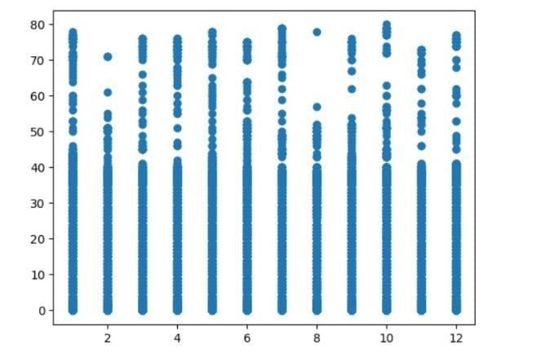 **observation**

The above graph is scatter graph of Sub_metering 1 with every month

# Scatter graph of Sub_metering 1

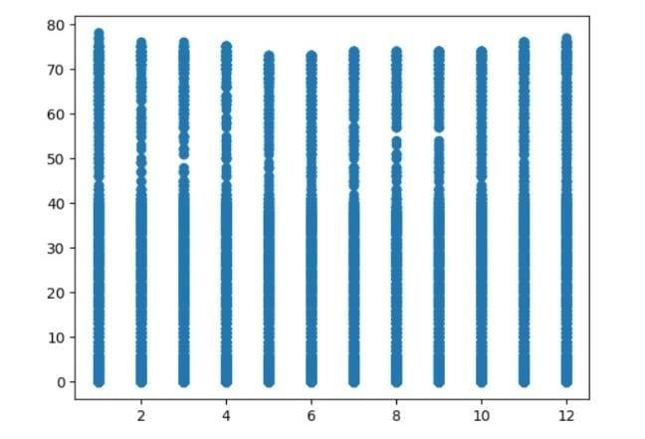 **observation**

The above graph is scatter graph of Sub_metering 2 with every month

# Scatter graph of Sub_metering 2

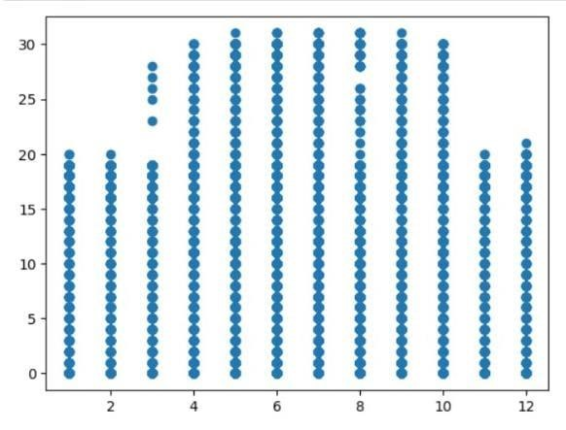 **observation**

The above graph is scatter graph of Sub_metering 3 with every month

# Heat map

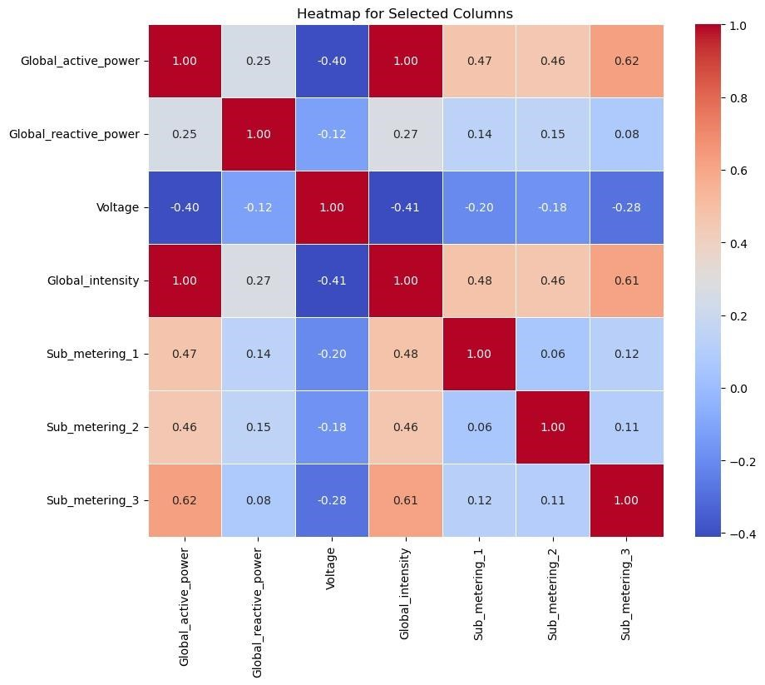

## observation

the above heat map gives relation between all parameters by seeing the above graph we can conclude that voltage is indirect proportional to all other paramerters if the relation value is positive they are directly proportional if the relation is negative value then they both are indirectly proportional.

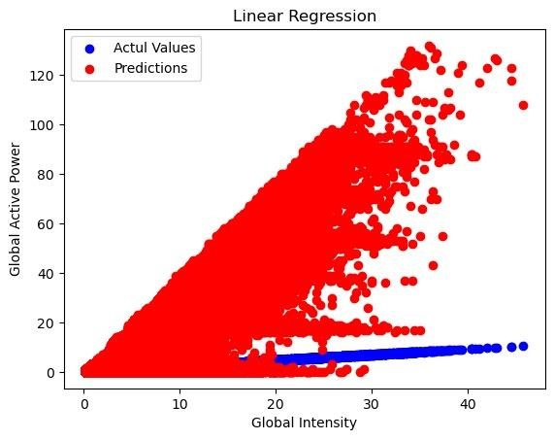

## Observation

By comparing global active power and global intensity we can conclude that by increase in global active power global intensity also increases.